Assignment 4 - Prognostics and Health Management
Deborah Aittokallio
Augmented Decision Making D7017B

Problem Description
This assignment looks at three steps of the PHM (Prognostics and Health Management) framework - anomaly detection, diagnosis, and prognosis. For the first two parts I used the MNIST handwritten digit dataset, treating digits 0-8 as normal data and digit 9 as the anomaly class. For prognosis I used the NASA C-MAPSS FD001 dataset which simulates turbofan engine degradation over time, and the goal is to predict how many cycles an engine has left before it fails.

Method of Solution

Part I - Anomaly Detection
The images are 28x28 grayscale pixels, normalised to mean=0.1307 and std=0.3081, giving each image a 784-dimensional input vector. I trained an autoencoder only on digits 0-8 so it learns to reconstruct normal-looking digits well. The architecture compresses from 784 down to just 8 neurons in the bottleneck - a tight squeeze that forces the network to generalise. When digit 9 comes in at test time, the network has never seen that shape before so it reconstructs it badly, giving a higher error. I set the threshold at mean + standard deviation of the reconstruction errors on a held-out validation set of normal digits only, so the anomalies can't inflate their own cutoff.

Part II - Diagnosis
I applied K-Means clustering with k=9 to group the digit classes without using labels. Before clustering I reduced the data from 784 dimensions to 50 using PCA, raw pixel distances mostly measure brightness rather than shape, so the clustering works much better in the reduced space. I used the elbow method and silhouette score to confirm k=9 is a reasonable choice, which lines up with the 9 real digit classes in the dataset.

Part III - Prognosis
Using the FD001 subset, I kept 17 of the 21 sensors after dropping the four that never change. RUL (Remaining Useful Life) is capped at 125 cycles since early engine behaviour doesn't vary much between engines. I used 30-cycle sliding windows and trained both an SVR and an LSTM to predict how many cycles are left. The LSTM reads the window as a time sequence while SVR just sees a flat list of numbers, so they approach the same problem differently.

Result Figures
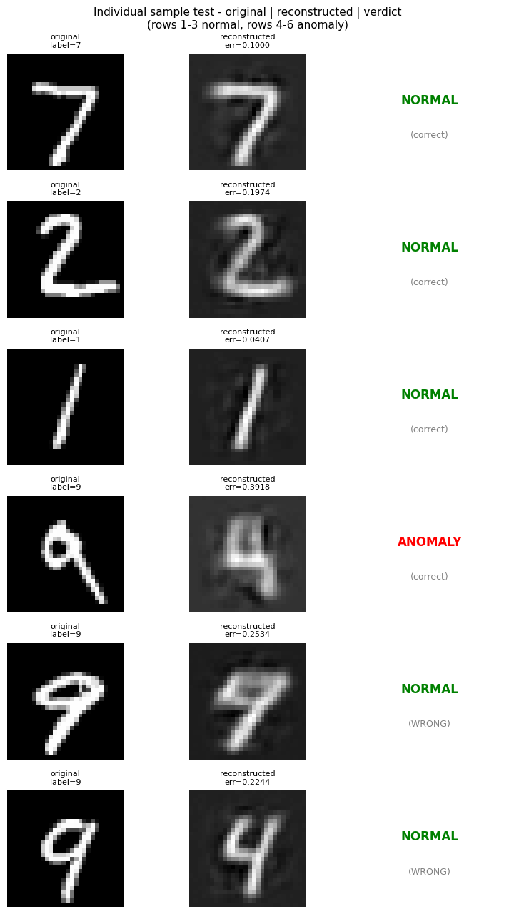
Fig 1. Individual sample test - original image, reconstruction, and verdict. Rows 1-3 normal, rows 4-6 anomaly (digit 9).
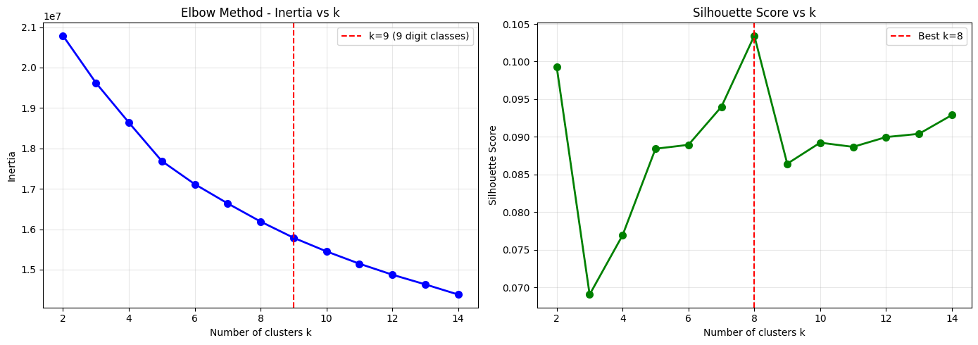
Fig 2. Elbow method (inertia) and silhouette score across k=2-14. Both point near k=9, matching the 9 digit classes.
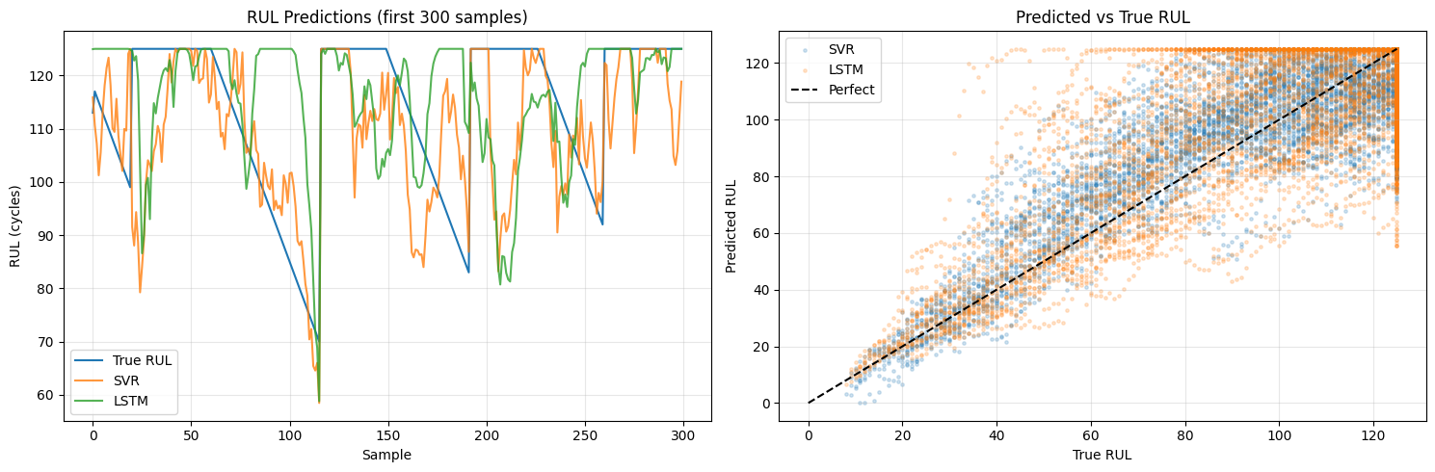
Fig 3. SVR vs LSTM RUL predictions (left) and predicted vs true scatter plot (right).

Observations and Reflections
- The bottleneck size made a big difference for anomaly detection. With 64 neurons the model was loose enough to partially reconstruct digit 9, so the error barely stood out. Shrinking it to 8 forced the model to compress harder, and digit 9 reconstructions became noticeably worse. About 45% of anomalies were caught, which is much better than the 9% I got before fixing the threshold calculation.
- For clustering, it was interesting to see how much PCA helped. On raw pixels the silhouette score peaked at k=2 because the distances were dominated by how bright the image was overall. Once I reduced to 50 components the curve looked much more meaningful and pointed near k=9, which is exactly what we'd expect given the 9 digit classes.
- On prognosis, both SVR and LSTM follow the downward RUL (Remaining Useful Life) trend but struggle when RUL gets low, which is also the most important region to get right in a real maintenance setting. The LSTM produces smoother predictions because it sees the degradation unfolding over 30 cycles in order, while SVR just gets a snapshot with no sense of time.

